SUMMER INTERNSHIP REPORT
A Study of Trading Operations, NNF Connectivity and Member Support Services at NuSummit
Submitted in partial fulfilment for the award of the degree of
MASTER OF MANAGEMENT STUDIES
FINANCE
UNIVERSITY OF MUMBAI

Student | Details
Name | Sanket S. Parsekar
Roll No. | M-16143
Programme | MBA / MMS – Finance
Academic Year | 2025–2026
Company | NuSummit, Kurla, Mumbai
Department | Trade Operations Support
Internship Period | 10 May 2026 to 09 July 2026
Project Guide | Dr. Rahul N. Wadekar

CERTIFICATE
This is to certify that Mr. Sanket Santosh Parsekar, Roll No. M-16143, student of Master of Business Administration (MBA) – Finance, Semester III, Navinchandra Mehta Institute of Technology and Development, University of Mumbai, has successfully completed his Summer Internship Programme at NuSummit, Kurla, Mumbai, in the Trade Operations Department.
The internship was completed during the period from 10 May 2026 to 09 July 2026.
The student has prepared the internship report titled “A Study of Trading Operations, NNF Connectivity and Member Support Services at NuSummit” as a part of the academic requirements of the MBA – Finance programme.
During the internship, the student gained practical exposure to Trade Operations, NNF-related support activities, Trading Member queries, connectivity-related processes, testing activities, documentation and stakeholder coordination.
Signatory | Designation
Dr. Rasika Mallya | Director
Dr. Rahul N. Wadekar | Project Guide
External Examiner | External Examiner

DECLARATION
I, Sanket Santosh Parsekar, Roll No. M-16143, hereby declare that the Summer Internship Programme report titled “A Study of Trading Operations, NNF Connectivity and Member Support Services at NuSummit” has been prepared by me as a part of the academic requirements of the MBA – Finance programme of the University of Mumbai.
This report is based on my learning, observations and practical exposure during my two-month internship at NuSummit, in the Trade Operations Department, from 10 May 2026 to 09 July 2026.
The information presented in this report is intended for academic purposes. Confidential information such as passwords, member IDs, IP addresses, internal ticket numbers, proprietary configurations and other sensitive operational information has not been disclosed.
I further declare that this report has not been submitted previously to any other institution or university for the award of any degree or qualification.
Field | Entry
Name | Sanket Santosh Parsekar
Roll No. | M-16143
Place | Mumbai
Date | ____________

ACKNOWLEDGEMENT
I would like to express my sincere gratitude to everyone who supported me during my Summer Internship Programme at NuSummit.
First, I would like to thank my company mentor, Mr. Ankur Lad, for his guidance, support and valuable inputs throughout the internship. His practical explanations helped me understand the working of Trade Operations and the importance of providing accurate and timely support to Trading Members.
I am also thankful to the entire Trade Operations team for giving me an opportunity to learn through practical exposure. Working with the team helped me understand various aspects of NNF support, connectivity, technical queries, testing activities, documentation and stakeholder coordination.
I would also like to thank the faculty members and management of Navinchandra Mehta Institute of Technology and Development for providing the academic framework and opportunity to undertake this Summer Internship Programme.
The internship helped me connect my classroom knowledge of finance and capital markets with actual workplace practices and improved my communication, problem-solving, coordination and professional skills.

EXECUTIVE SUMMARY
The Summer Internship Programme is an important part of the MBA curriculum because it provides practical exposure to concepts learned in the classroom. I completed my two-month internship at NuSummit, Kurla, Mumbai, in the Trade Operations Department, from 10 May 2026 to 09 July 2026.
The internship provided practical exposure to Trade Operations Support with a combination of technical and operational responsibilities. My work involved supporting NNF/CTCL products, trading terminals, connectivity, login access, user IDs, member mapping and NNF approvals.
I also supported NEAT functionality, TCP/IP scenarios, pre-trade reporting, UAT, mock sessions, simulation activities and system readiness. A significant part of the work involved handling Trading Member queries and coordinating with internal technical teams whenever technical intervention was required.
In addition to daily query handling, I supported colleagues with complex query resolution, participated in knowledge sharing and conducted training sessions for new joiners covering NNF/CTCL, NEAT, Connectivity, Trading Member access and the operational support workflow.
Overall, the internship helped bridge the gap between MBA Finance theory and practical financial-market operations, while strengthening communication, problem-solving, coordination, time-management and professional skills.

INTERNSHIP AT A GLANCE
The following snapshot summarises the numerical information directly associated with the internship scope and the responsibilities described in this report.
Metric | Value | Interpretation
Internship duration | 2 months | 10 May 2026 to 09 July 2026
Approx. daily query handling | 4–5 | Reported average handled per day
Major role groups | 4 | Product support, testing/readiness, team coordination, training
Training topics listed | 5 | NNF/CTCL, NEAT, Connectivity, Trading Member access, support workflow
Primary function | Trade Operations Support | Technical + operational exposure

INDEX
Sr. No. | Particulars | Page No.
1 | Introduction | 9
2 | Company Profile – NuSummit | 10
3 | Industry and Functional Overview | 11
4 | Objectives of the Internship | 12
5 | Department Overview – Trade Operations Support | 13
6 | Roles and Responsibilities | 14
7 | NNF / CTCL Product Support | 15
8 | NEAT, Connectivity and TCP/IP Support | 16
9 | Testing, UAT, Mock and Simulation Activities | 17
10 | Trading Member Support and Query Resolution | 18
11 | Team Coordination and Knowledge Sharing | 19
12 | Training of New Joiners | 20
13 | Skills and Learning Outcomes | 21
14 | Detailed Work Analysis | 22
15 | Technical Concepts Learned | 23
16 | Operational Workflow and Controls | 24
17 | Query Classification and Handling Framework | 25
18 | MBA Finance Linkage | 26
19 | Professional Development | 27
20 | Challenges and Problem-Solving Approach | 28
21 | Observations and Findings | 29
22 | Conclusion and Suggestions | 30
23 | Bibliography | 31
24 | Appendix – Activity Matrix | 32

1. INTRODUCTION
The Summer Internship Programme is designed to provide practical exposure to the working environment and to help students connect academic concepts with real organisational practices. As an MBA – Finance student, the internship provided an opportunity to understand the operational side of financial markets and the role of technology in supporting trading activities.
I completed my two-month internship at NuSummit, Kurla, Mumbai, in the Trade Operations Support function. The role involved a combination of technical and operational work, including trading-product support, access and connectivity-related processes, testing activities and Trading Member query resolution.
The internship environment provided exposure to day-to-day operational support where accuracy, response time, communication and coordination were important. Queries could relate to trading terminals, login access, user IDs, member mapping, connectivity, NNF approvals, NEAT functionality, testing or system readiness.
The experience demonstrated that financial-market operations are not limited to finance concepts alone. Technology, processes, communication and operational controls work together to support a reliable trading environment.
Key Points
- Practical exposure to Trade Operations Support
- Technical and operational query handling
- Connectivity and trading access support
- Testing and system-readiness activities
- Training and knowledge sharing

2. COMPANY PROFILE – NUSUMMIT
NuSummit was the organisation where I completed my Summer Internship Programme. I was associated with the Trade Operations Department at the Kurla, Mumbai location. My internship exposure was primarily related to Trade Operations Support and the processes used for supporting trading-related products and Trading Members.
The internship gave me an opportunity to observe how a specialised support function works in a technology-enabled financial-market environment. The work required coordination between operational requirements and technical requirements, especially when a query could not be resolved through routine checks.
Within the scope of the internship, I worked on NNF/CTCL product support, NEAT-related support, connectivity, access management, member mapping, approvals, testing and query resolution. The role also involved assisting colleagues and sharing knowledge with new joiners.
Because the work involved operational systems, confidentiality was important. Sensitive operational information is intentionally excluded from this academic report.
Key Points
- Organisation: NuSummit
- Location: Kurla, Mumbai
- Function: Trade Operations Support
- Internship duration: 10 May 2026 to 09 July 2026

3. INDUSTRY AND FUNCTIONAL OVERVIEW
Trading operations support is an important functional area in a technology-enabled financial market environment. Trading Members and their users depend on stable access, correct configuration, connectivity and timely operational assistance.
From my internship experience, Trade Operations Support can be understood as a bridge between Trading Members, operational teams and technical teams. A query may begin as a user-level issue but may require checking access, mapping, connectivity, product configuration or technical conditions before a resolution can be provided.
NNF/CTCL and related trading access processes require operational discipline because multiple conditions may need to be checked. Similarly, UAT, mock and simulation activities require coordination and readiness so that testing can be completed systematically.
The internship therefore provided practical understanding of how operational processes support the technology used for trading activities.
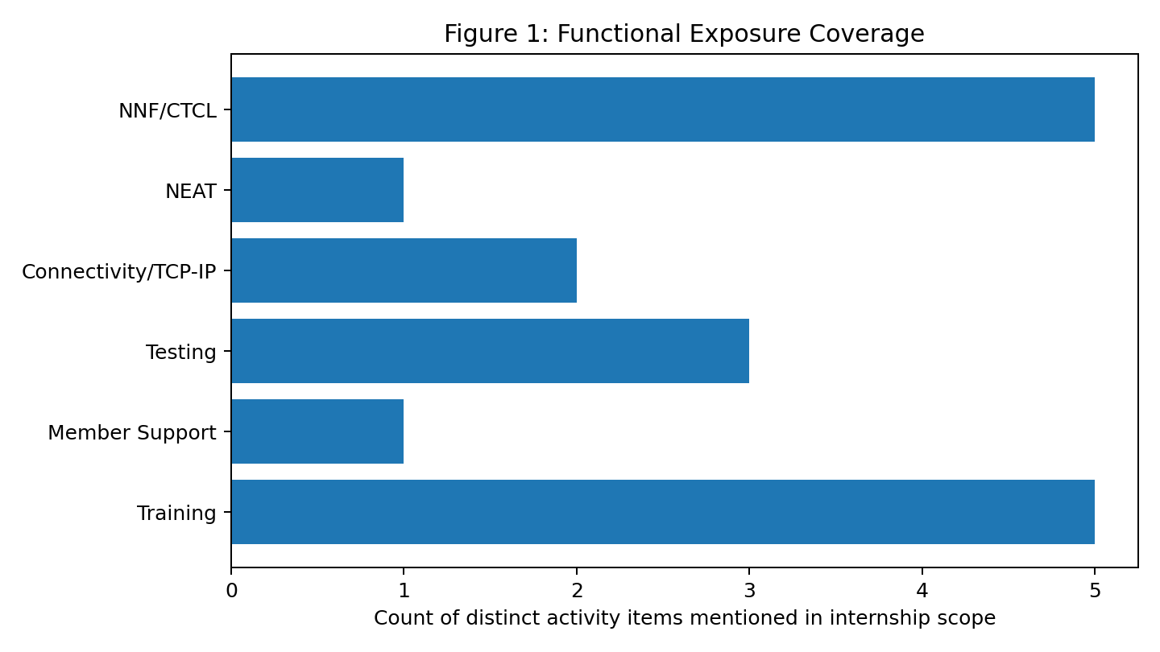
Figure 1: Functional exposure coverage based on the distinct activity items listed in the internship scope.

4. OBJECTIVES OF THE INTERNSHIP
The primary objective of the internship was to gain practical exposure to Trade Operations Support and understand how technical and operational activities are coordinated in a financial-market environment.
The internship also aimed to develop the ability to understand Trading Member queries, perform appropriate operational checks, communicate clearly, coordinate with relevant teams and support timely resolution.
Another objective was to understand NNF/CTCL, NEAT, connectivity, access, member mapping and testing-related processes at a practical level. The training responsibility further helped develop the ability to explain operational processes to new joiners.
Key Points
- Understand Trade Operations Support
- Learn NNF/CTCL and NEAT-related support
- Understand connectivity and access processes
- Gain exposure to UAT, mock and simulation
- Develop communication and coordination skills
- Support knowledge sharing and onboarding

5. DEPARTMENT OVERVIEW – TRADE OPERATIONS SUPPORT
The Trade Operations Support function handles day-to-day operational requirements associated with trading products and Trading Member support. During my internship, the function involved responding to queries, checking relevant details, coordinating with internal technical teams and communicating updates.
The department required a balance between technical understanding and operational discipline. A support professional needs to understand the nature of the query, identify the relevant product or process, perform available checks and escalate appropriately when technical intervention is required.
The work environment also involved teamwork. Complex queries were discussed with colleagues, and knowledge was shared to improve consistency in handling recurring issues.
Key Points
- Query intake and understanding
- Initial checks and validation
- Coordination with technical teams
- Follow-up and closure
- Documentation and knowledge sharing

6. ROLES AND RESPONSIBILITIES
During my two-month internship at NuSummit, I worked in Trade Operations Support and handled a combination of technical and operational responsibilities. My work was focused on supporting trading products, Trading Member access, connectivity, testing and day-to-day query resolution.
My key responsibility was to manage NNF/CTCL product support covering trading terminals, connectivity, login access, user IDs, member mapping and NNF approvals. This required understanding the relationship between the user, access requirement and operational process.
I also supported NEAT functionality, TCP/IP scenarios, pre-trade reporting, UAT, mock sessions, simulation and system readiness. These activities helped me understand the importance of testing and validation before operational use.
Along with individual query handling, I supported team management and work coordination. I assisted colleagues with complex queries, participated in knowledge sharing and helped maintain smooth operations.
I also conducted training sessions for new joiners. The sessions covered Trade Operations products and processes such as NNF/CTCL, NEAT, connectivity, Trading Member access and the operational support workflow.
Responsibility group | Representative activities
Product support | NNF/CTCL, trading terminals, login access, user IDs, member mapping, NNF approvals
Technical support | Connectivity, TCP/IP scenarios, NEAT functionality, pre-trade reporting
Testing & readiness | UAT, mock sessions, simulation, system readiness
Team & training | Complex query support, work coordination, knowledge sharing, new-joiner training

7. NNF / CTCL PRODUCT SUPPORT
NNF/CTCL product support formed an important part of my internship responsibilities. The work involved supporting trading terminals and related access and operational requirements.
One aspect of the work involved login access and user IDs. When users faced access-related queries, the issue needed to be understood correctly before the appropriate operational action or coordination could be initiated.
Member mapping was another important area. Correct mapping is necessary for the intended access and operational flow. Queries related to mapping therefore required careful checking and coordination.
NNF approvals were also part of the support activities. The process required attention to operational requirements and proper coordination so that requests could be handled systematically.
Through this work, I learned the importance of accuracy and process discipline in trading support.
Key Points
- Trading terminal support
- Login and user ID support
- Member mapping
- NNF approvals
- Connectivity-related support

8. NEAT, CONNECTIVITY AND TCP/IP SUPPORT
During the internship, I gained practical exposure to NEAT functionality and connectivity-related scenarios. These activities helped me understand how trading access depends on technical connectivity and correct operational setup.
TCP/IP scenarios formed part of the technical support exposure. From an operations perspective, the key requirement was to understand the nature of the reported issue, collect relevant information and coordinate with the appropriate technical team when required.
Connectivity issues can affect access and trading-related activities, so timely communication and systematic checking were important. I learned to distinguish between issues that could be addressed through routine operational checks and those requiring technical intervention.
Pre-trade reporting and system readiness were also part of the exposure. These activities reinforced the importance of validating readiness before testing or operational use.
Key Points
- NEAT functionality
- Connectivity scenarios
- TCP/IP-related support
- Pre-trade reporting
- System readiness

9. TESTING, UAT, MOCK AND SIMULATION ACTIVITIES
Testing-related activities were an important part of the internship because they provided exposure to processes used before operational deployment or readiness.
I supported UAT activities where the objective was to validate expected functionality in a controlled environment. Mock sessions and simulation activities provided further exposure to structured testing and readiness checks.
These activities required coordination, attention to process and communication. The experience showed me that testing is not only a technical exercise; operational teams also have an important role in ensuring that requirements are understood and issues are communicated correctly.
Supporting these activities improved my ability to follow structured processes and understand the importance of validation before moving towards operational readiness.
Key Points
- UAT support
- Mock sessions
- Simulation activities
- System readiness
- Issue communication and coordination

10. TRADING MEMBER SUPPORT AND QUERY RESOLUTION
A major part of my internship involved supporting Trading Member queries. On average, I handled approximately 4–5 queries per day. The queries varied depending on access, connectivity, product functionality, testing or operational requirements.
The first step in query resolution was to understand the exact issue. Clear understanding helped determine whether the query was related to user access, product support, connectivity, mapping, testing or another operational area.
Where the issue could be handled through routine operational checks, I supported the required process. Where technical intervention was necessary, I coordinated with the internal technical team and followed up for resolution.
This experience improved my communication and problem-solving skills. I learned that a good support process requires technical understanding together with patience, accurate information gathering and clear communication.
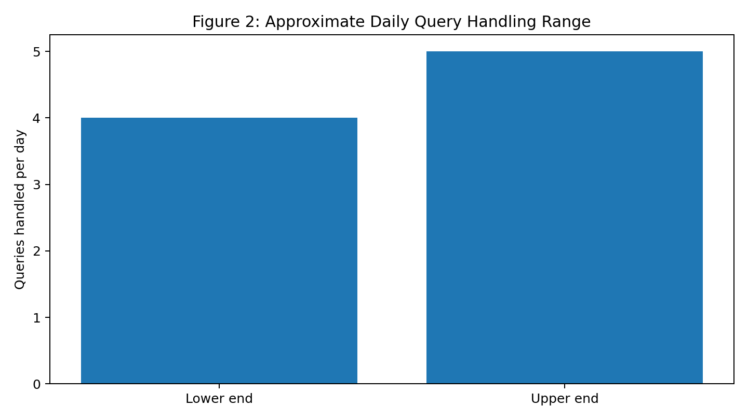
Figure 2: Approximate daily query handling range reported during the internship.

11. TEAM COORDINATION AND KNOWLEDGE SHARING
Trade Operations Support is a team-oriented function. During my internship, I supported colleagues with complex query resolution and participated in work coordination.
When a query required additional understanding, discussions with experienced colleagues helped identify the appropriate approach. This created an environment of knowledge sharing and reduced dependency on individual knowledge.
I also learned that documenting and communicating the resolution approach can help colleagues handle similar queries more efficiently in the future.
Team coordination helped me understand professional workplace practices such as prioritisation, escalation, follow-up and shared responsibility.
Key Points
- Complex query support
- Work coordination
- Knowledge sharing
- Escalation and follow-up
- Collaborative problem solving

12. TRAINING OF NEW JOINERS
One of the additional responsibilities I handled during the internship was conducting training sessions for new joiners. The training covered Trade Operations products and processes relevant to the support function.
The sessions included NNF/CTCL, NEAT, connectivity, Trading Member access and the operational support workflow. The objective was to give new joiners a structured understanding of the products and the way queries are handled.
Conducting training required me to explain processes in a simple and systematic manner. It also required me to anticipate questions and provide practical examples without disclosing confidential operational information.
This responsibility strengthened my presentation, communication and knowledge-sharing skills and helped me understand the importance of effective onboarding.
Training topic | Coverage
NNF / CTCL | Product purpose, support approach, access-related processes
NEAT | Functionality and common operational support considerations
Connectivity | Basic support checks and escalation logic
Trading Member access | User access, IDs and member mapping
Support workflow | Query understanding, checks, coordination, follow-up and closure

13. SKILLS AND LEARNING OUTCOMES
The internship resulted in learning across technical, operational and professional areas. I developed a practical understanding of how Trade Operations Support works in a technology-enabled financial-market environment.
Technical learning included exposure to NNF/CTCL, NEAT, connectivity, TCP/IP scenarios, UAT, mock and simulation activities, user access and member mapping.
Operational learning included query handling, prioritisation, coordination, escalation, follow-up and system readiness.
Professional learning included communication, teamwork, time management, problem solving and training delivery.
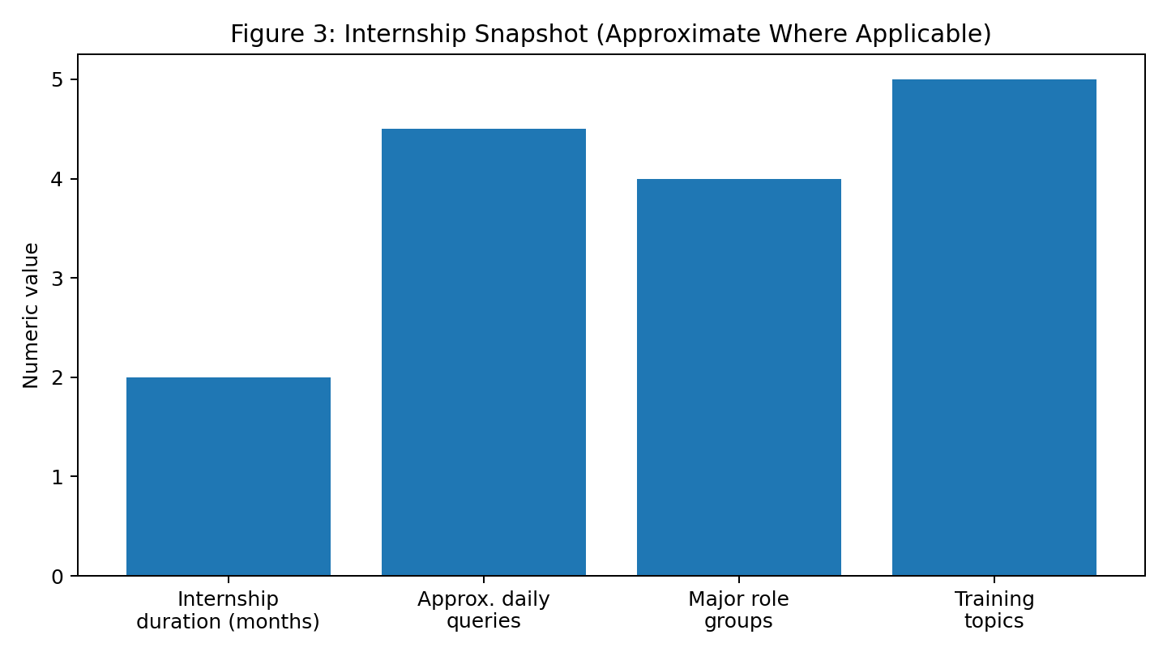
Figure 3: Internship snapshot using the quantitative details available from the internship scope. The 4.5 figure is a visual midpoint of the stated 4–5 daily query range.

14. DETAILED WORK ANALYSIS
The practical work performed during the internship can be understood through four connected dimensions: product support, technical coordination, testing and team enablement. Each dimension contributed to the overall objective of maintaining smooth operational support for Trading Members.
Product support focused on NNF/CTCL, trading terminals, login access, user IDs, member mapping and approvals. Technical coordination involved connectivity, TCP/IP scenarios, NEAT functionality and related issue investigation. Testing exposure covered UAT, mock sessions, simulation and readiness activities.
Team enablement included supporting colleagues with complex queries and conducting training for new joiners. These activities broadened my understanding from individual ticket resolution to the wider operational workflow.
The combined exposure helped me see how a support role contributes to continuity, responsiveness and process discipline in a technology-driven financial-market environment.
Work dimension | Examples from internship | Learning outcome
Product support | NNF/CTCL, terminals, access, IDs, mapping, approvals | Process understanding
Technical coordination | Connectivity, TCP/IP, NEAT | Issue diagnosis and escalation
Testing | UAT, mock, simulation, readiness | Validation mindset
Team enablement | Complex queries, coordination, training | Collaboration and knowledge sharing

15. TECHNICAL CONCEPTS LEARNED
The internship introduced me to several technical concepts that are relevant to trading operations. I developed practical familiarity with NNF/CTCL support, NEAT functionality and connectivity-related scenarios.
TCP/IP exposure helped me understand that connectivity is dependent on technical communication between systems and that operational teams need to capture and communicate the relevant details before technical troubleshooting can proceed.
I also learned the operational relevance of UAT, mock sessions and simulation. These activities demonstrated how testing environments can be used to validate expected behaviour and readiness before business usage.
The learning was not limited to terminology; it involved understanding how technical concepts translate into actual user-support requirements.
Key Points
- NNF / CTCL product support concepts
- NEAT functionality
- Connectivity and TCP/IP awareness
- User access and member mapping
- UAT, mock and simulation concepts
- System-readiness checks

16. OPERATIONAL WORKFLOW AND CONTROLS
Operational support requires a structured workflow so that queries are understood, investigated, escalated where necessary and followed through to closure. During the internship, I learned the value of following a repeatable process rather than responding only to the symptom reported by a user.
An important control is validation of the query details. The next control is checking the relevant access, product or connectivity conditions. When an issue requires a different team, the escalation should contain the information needed for further investigation.
Follow-up is another important control because a technically escalated issue still requires operational ownership until a clear update or closure is communicated to the concerned user.
This workflow improved my process discipline and helped me understand how support quality depends on consistency as much as technical knowledge.
Key Points
- Validate the reported issue
- Check the relevant product or access condition
- Escalate with complete information when required
- Track the response and follow up
- Communicate closure clearly
- Respect confidentiality throughout the process

17. QUERY CLASSIFICATION AND HANDLING FRAMEWORK
During the internship, the daily query volume was approximately 4–5 queries. The queries could be grouped by the type of operational or technical requirement involved. The classification below is a framework for describing the work scope; it is not a statistical distribution of the actual query volume.
Access-related queries included login access, user IDs and member mapping. Product-related queries involved NNF/CTCL and NEAT. Technical queries involved connectivity and TCP/IP scenarios. Testing-related queries involved UAT, mock sessions, simulation and system readiness.
Using a classification framework helps a support professional decide what information to collect, what checks to perform and which team may need to be involved. It also supports knowledge sharing because recurring categories can be documented for future reference.
Query category | Typical examples | First response focus
Access | Login, user ID, member mapping | Verify user/access context
Product | NNF/CTCL, NEAT | Identify product and expected function
Connectivity | Connectivity, TCP/IP | Capture technical context and coordinate
Testing | UAT, mock, simulation | Check test scenario and readiness
Approval | NNF approvals | Verify process requirement and status

18. MBA FINANCE LINKAGE
The internship provided a practical connection between MBA Finance learning and financial-market operations. Academic concepts about capital markets are supported in practice by technology, operations, controls and reliable processes.
The exposure to trading terminals, member support and pre-trade reporting helped me understand that market participation requires more than financial knowledge. Users need controlled access, functioning connectivity and timely support.
The internship also strengthened my understanding of operational risk from a practical perspective. Incorrect mapping, incomplete information or delayed communication can create operational difficulties, which is why systematic checks and escalation are important.
The experience therefore complemented classroom learning by showing how financial-market functions are implemented and supported in an organisation.
Key Points
- Capital-market concepts in operational practice
- Technology support for trading
- Operational risk awareness
- Importance of controls and process discipline
- Role of communication in financial operations

19. PROFESSIONAL DEVELOPMENT
The internship contributed to my professional development beyond product knowledge. Regular query handling improved my ability to listen carefully, identify the key issue and communicate a response in a structured way.
Supporting colleagues with complex queries improved teamwork and confidence in collaborative problem solving. Exposure to technical teams also helped me understand how responsibilities are shared across functions.
Conducting training sessions for new joiners improved presentation and explanation skills. I learned that knowing a process and being able to teach that process are different skills; training requires clarity, sequencing and the ability to answer practical questions.
The overall experience strengthened my readiness for roles that combine finance-domain knowledge with technology-enabled operations.
Key Points
- Communication and professional etiquette
- Teamwork and collaboration
- Problem solving
- Training and presentation
- Time management and prioritisation

20. CHALLENGES AND PROBLEM-SOLVING APPROACH
One of the main challenges in Trade Operations Support is that the same type of user-reported problem can have different underlying causes. Therefore, understanding the exact issue is important before deciding the next step.
Another challenge is balancing multiple queries and ensuring that follow-up is not missed. The internship helped me understand the importance of prioritisation and maintaining clear communication.
Complex queries sometimes required coordination with technical teams. In such cases, collecting relevant information and communicating the issue clearly helped make the escalation more effective.
Training new joiners also required converting practical knowledge into a structured explanation. This improved my ability to break down processes into understandable steps.
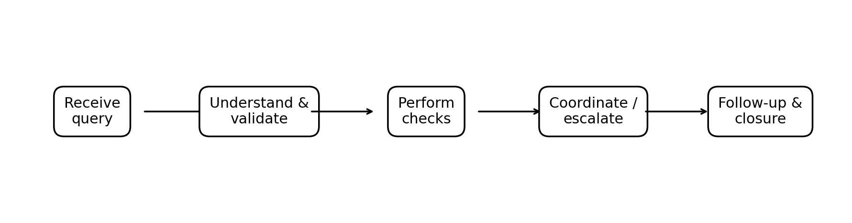
Figure 4: Generalised query-resolution workflow followed as an operational support framework.

21. OBSERVATIONS AND FINDINGS
Based on my internship exposure, I observed that Trade Operations Support requires close coordination between people, processes and technology.
Trading Member support depends on timely communication and accurate understanding of the reported issue. A technically correct response is useful only when it is communicated clearly and followed through to closure.
I also observed that testing and readiness activities are important because they provide an opportunity to identify issues in a controlled environment.
Knowledge sharing within the team can improve consistency in query handling. Training and structured onboarding can also help new joiners become productive more quickly.
Overall, the internship showed me how finance and technology are interconnected in modern trading operations.
Key Points
- People–process–technology coordination
- Importance of timely support
- Value of structured testing
- Knowledge sharing
- Finance and technology integration

22. CONCLUSION AND SUGGESTIONS
The Summer Internship Programme at NuSummit provided me with practical exposure to Trade Operations Support. Over the two-month internship, I worked on technical and operational activities involving NNF/CTCL, NEAT, connectivity, access, member mapping, approvals, testing and Trading Member queries.
The internship helped me understand the importance of accuracy, communication, coordination and timely support in an operational environment. Handling daily queries and supporting complex cases improved my problem-solving ability.
Conducting training sessions for new joiners further strengthened my communication and knowledge-sharing skills. It also helped me understand the processes more deeply because explaining a process requires clarity about each step.
From an academic perspective, the internship helped connect MBA Finance concepts with practical financial-market operations. It demonstrated how technology-enabled processes support trading activities and how operational teams contribute to system readiness and user support.
Suggestions include maintaining structured knowledge documentation for recurring queries, continuing regular training for new joiners, and strengthening coordination between operational and technical teams for faster issue resolution.
Key Points
- Continue structured onboarding
- Maintain knowledge documentation
- Encourage cross-team coordination
- Use systematic query tracking
- Continue practical training

23. BIBLIOGRAPHY
The primary basis for this report is the practical learning, observations and work exposure obtained during the Summer Internship Programme at NuSummit in the Trade Operations Department.
The report also follows the academic requirements and structure of the Summer Internship Programme prescribed for the MBA – Finance programme.
Key Points
- Summer Internship Programme experience at NuSummit, Trade Operations Department
- Academic guidance provided by Navinchandra Mehta Institute of Technology and Development
- Personal work observations and learning during the internship

24. APPENDIX – ACTIVITY MATRIX
The following matrix summarises the major activities covered during the internship. It is intended as a quick reference to the operational and technical scope of the training.
Area | Activity / Exposure | Nature of Work
NNF/CTCL | Trading terminals | Product support
NNF/CTCL | Login access and user IDs | Operational support
NNF/CTCL | Member mapping | Access / configuration support
NNF/CTCL | NNF approvals | Process support
Connectivity | Connectivity scenarios | Technical coordination
Connectivity | TCP/IP scenarios | Technical support exposure
NEAT | NEAT functionality | Product support
Reporting | Pre-trade reporting | Operational support
Testing | UAT | Testing / validation
Testing | Mock sessions | Testing / readiness
Testing | Simulation | Testing / readiness
Support | Trading Member queries | Query handling
Team | Complex query resolution | Team coordination
Training | New joiner training | Knowledge sharing

